JMS Connector design

Goal of this document
This document globally describes the JMS Connector design.

Features
The JMS connector is designed to be used with JMS (Java Messaging System) 1.1 compliant messaging software. Examples of this software are IBM Websphere MQ, OpenJMS, ActiveMQ, ForianoMQ, Sun J2EE etc.

A list of features:
- Support for queue’s and topic’s (not for XA interfaces)
- Message triggering (as soon as a message arrives on a specific destination a configurable SOAP call can be fired).
- Multiple messaging systems per connector
- SendMessage, GetMessage (blocking or non-blocking) and RequestMessage (request/response).
- Message options like expiration, persistence, JMS type, text messages, byte messages, correlation, priority and properties
- Message formats like clear text, XML, base64 encoded and BTC (binary transformation channel) protocols.
- Configurable access rights to destinations like read, write or read/write
- Configurable error destinations
- Transaction support
- Possibility to create method’s with predefined message options

Requirements
The JMS connector requires (at least) Cordys 4.2 C1, as it uses the log4j framework and JMX.

Class diagram
The class diagram below is a simple representation of the structure of the connector:
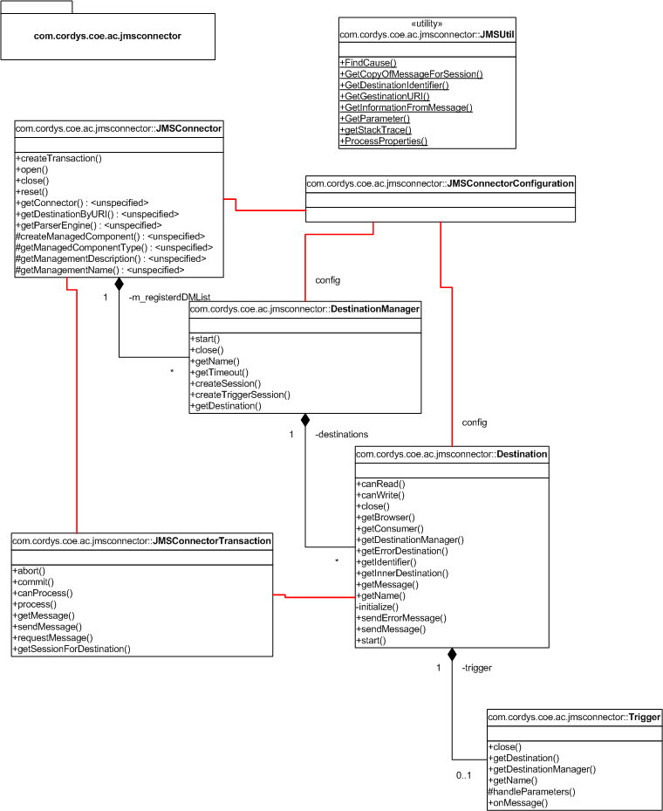

Things to be implemented/improved in future releases
There are a few things that can be implemented in future releases like:
- Cordys 4.2 C2 logging and JMX framework (this must be done to keep it compatible as the API’s are changed)
- Session pooling (can improve performance, remark: a session is destination manager dependent, so pool per destination manager)
- WYCTO (Whatever You Can Think Of)

